DarkBASIC Professional
QuickStart Tutorial

All rights reserved. No part of this document may be reproduced or transmitted in any form or by any means, electronic or mechanical, including photo-copying, recording, or by any information storage and retrieval system, without written permission from Dark Basic Software Limited, except for the inclusion of brief quotations in a review.

Copyright © 2004 by The Game Creators Limited

Warning and Disclaimer

This tutorial is designed to provide information about DarkBASIC Professional. Every effort has been made to make this tutorial as complete and as accurate as possible, but no warranty or fitness is implied.

The information is provided on an “as is” basis. The author(s) and The Game Creators Limited shall have neither liability nor responsibility to any person or entity with respect to any loss or damage arising from the information contained in this document or from the use of the programs or source code that may accompany it.

Skyboxes

Introduction

In the beginning there was the game backdrop, either a black or colored kind of void. Next came the images used for backdrops. Outer space "shootem-up" games were the rage and star fields were the backdrops.

As technology and techniques improved, everyone began using skyboxes, the subject of this tutorial. In addition, there are skyspheres. Which should you use for your game? Some of the issues to consider include:

- Skyboxes require five or six images for each rendered "sky." These images (see Figure 2) are fairly straightforward but do have special requirements for orientation, field of view, and resolution.

- Skyspheres require only one image but it needs to be a special panoramic view made from a fisheye-lens camera.

- Skyboxes use square or rectangular images. Most PC graphic cards and software are designed to work best with square or rectangular images, not spherical. Because of this, skyboxes usually enjoy better performance than skyspheres.

- Some world / level editors have built-in functions for making a skybox or similar sky.

First, we are going to look at the basics of a skybox. Then we examine some key points about game program design for skyboxes, and finally we go into the details of DarkBASIC Professional skybox construction and operation.

Basics

Figure 1 - Skybox on matrix
Our skyboxes will be made from five sides, but that is because we are using a standard ground texture – skyboxes often comprise of 6 faces. The orientation used when making the pictures will later determine the exact commands used to make the skybox. See Figure 2 for an example of picture orientation. These images wrap around and form a cube.

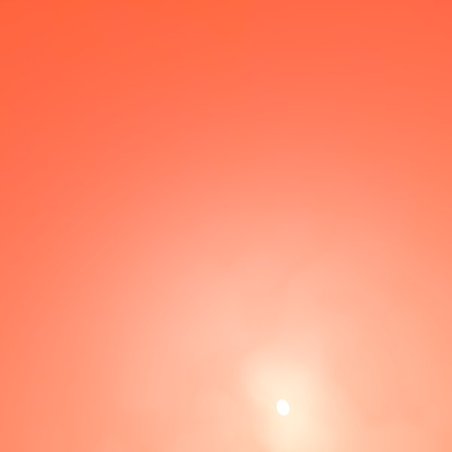

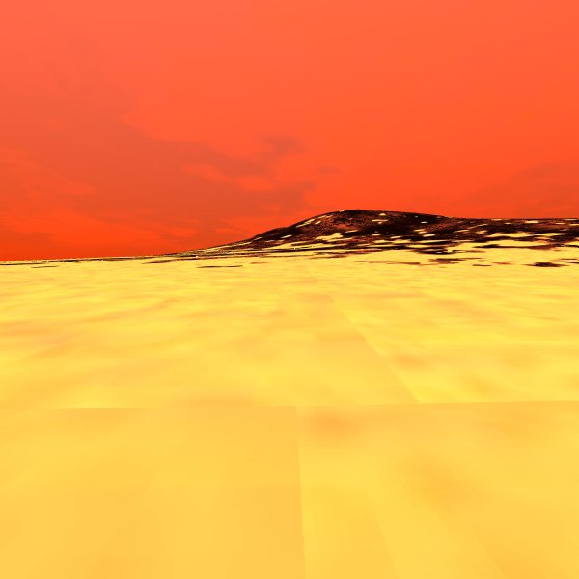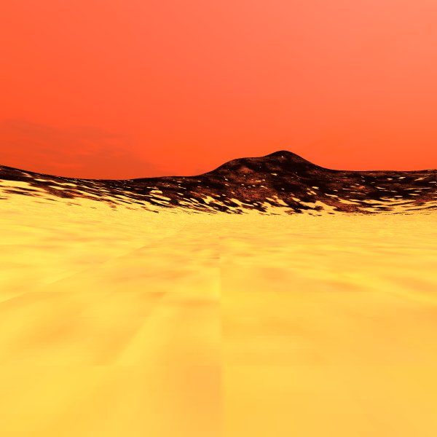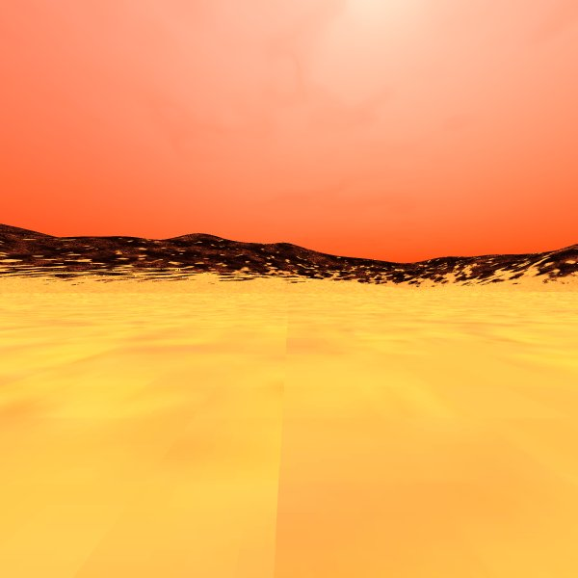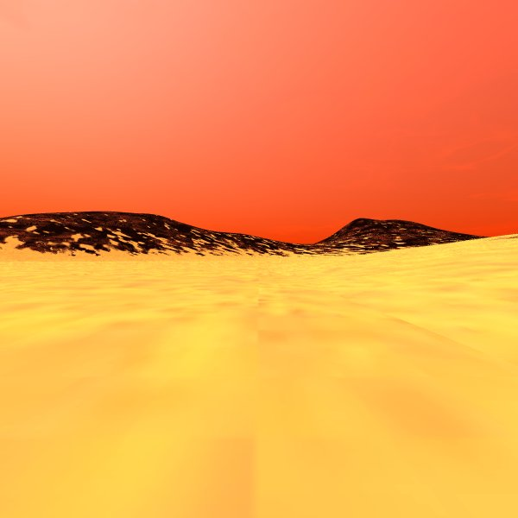

Top

Left
Back
Right
Front

Front side Top side and left side
(Hidden) Right side

Back side (facing viewer)

Figure 2 - Example skybox texture image set

Some graphics engines require that a single image composed of five or six images be "stitched together" into one. With DarkBASIC Professional and our skybox arrangement, we use five separate images as shown. When used, the sixth image goes on the bottom of the skybox.

In the world of DirectX each face has a specific name, they are as follows:

DirectX Name Real Name

Pos_X Front facing image
Pos_Y The top facing image (often the sky itself)
Pos_Z The face immediately on your left
Neg_X The back image
Neg_Y The bottom image (often the ground)
Neg_Z The face immediately to your right

Texture Packs such as SkyMATTER use this naming convention.

Each picture becomes a texture image for a "wall" of the skybox. A common perspective is to use a 90-degree field of view (FOV). See Figure 3. Note that the field of view can be exactly one image or parts of two images.

Regardless of whether the field of view encompasses exactly one frame or parts of two frames, the view from inside the skybox should have no visible seams showing.



Figure 3 - A seamless field of view (FOV)

There are two techniques to hide image seams. They are covered later in the section Program Design.
For the skybox, the player/camera (referred to from here on as just the "player") is positioned in the exact center (standing at ground level). The skybox and the player move in unison. The images textured on the inside of the skybox depict a sky and objects that are always out of reach of the player. As the player turns right or left, the skybox always maintains its original orientation. See Figure 4.

Y+ Z +

X+
Figure 4 - Skybox moves but does not turn. Player moves and turns.

For example, the player may start out facing the back of the skybox (the Z+ direction) and see high mountains and then turn left (X-) and see a city skyline in the distance. The player should be able to turn and move in any direction and the high mountains will always be in the Z+ direction.

Another style of skybox encloses the entire landscape instead of just the player's immediate world. This non-movable style skybox is appropriate for games with a very large outdoor area and likewise a large number of objects in the landscape with which the player can interact. This style skybox will not be illustrated here. See the sister tutorial on Skyspheres for an example of full landscape enclosure.

Program Design

Texture Mapping

Texture mapping is the process of laying a texture image onto an object in a 3D scene. The mapping involves the use of texture surface coordinates (u, v). Refer to Figure 5.

(0,0)
u
(u0,v0) (u1,v1)

(u2,u2)

Texture

v

Figure 5 - U / V Diagram

The image is applied to a polygon by the assignment of the texture coordinates to the polygon vertices. They index the texture image and are interpolated across the polygon to determine a texture image value for each pixel. Texture images are often repeated across an object's face. An example could be a 2D image of a section of a brick wall.

Images are loaded into the program with the Load Image command. A unique identifier is assigned to the image via the Image Number. Next, the texture is applied to the object by:

TEXTURE OBJECT Object Number, Image Number

There are many DarkBASIC Professional commands that affect the texturing of an object; but here we are primarily interested in these three:

SET OBJECT TEXTURE Object Number, Texture Mode, Mipmap Flag
SCALE OBJECT TEXTURE Object Number, UScale, VScale
SCROLL OBJECT TEXTURE Object Number, U-value, V-value

The Set Object Texture command will be explained in detail in the section Seamless Skyboxes - Use of Clamping, but first let's look at scaling and scrolling.

Scale Texture

Scaling an object texture refers to expanding or shrinking the texture image during the mapping process. The UScale and VScale parameter values in this command are centered on the value 1 (100%). Setting either UScale or VScale below 1 (i.e., 0.80) will shrink the texture image to 80 percent of its original size. Likewise, a setting of 1.25 will expand the image by 25 percent in the specified direction.

Scrolling Texture

Scrolling an object's texture moves the texture across the object face. The U-value shifts left or right (horizontally) and the V-value shifts up or down (vertically). These values, if containing other than a zero, will scroll the texture for each command execution. A value of 1 represents 100 percent, which means moving the entire width of the texture. A value of 0.01 would scroll 1 percent. On a 512-bit image this represents approximately a 5-pixel shift.

With all of the above in mind, we might come to the conclusion that the best texture to use might be one with the same resolution as the maximum display screen resolution. That means a 1024-bit texture maps to an object that is displayed 1-inch wide on a display screen at a 1024 x 768 resolution. This would mean no scaling or scrolling needed.

That's fine as long as the object maintains a 1-inch width and is always displayed "flat" to the screen (without perspective). The graphics hardware and software does its best to maintain a proper texture regardless. This is done via anti-aliasing and other techniques, which are outside the scope of this tutorial.

Now lets get on to our techniques of providing a seamless player image across multiple skybox texture images. There are two primary design areas to be considered: making the player view seamless, and skybox construction.

Seamless Skyboxes - Enlarging the Image

There are two common techniques. The first involves the use of a skybox where the walls and textures are slightly larger than the original images. The exact enlargement factor to be used is determined by experimentation and the screen resolution. The objective is alignment of the original pixels between all adjoining image edges. The correct factor will likely be in the range of 1.005 to 1.010 times the original width.

This makes use of the ability to have one object go through another and the textures blend well. Enlarged skybox walls are employed in the tutorial example program Tut03.dba. Refer to Figures 6, 7 and 8 for examples.
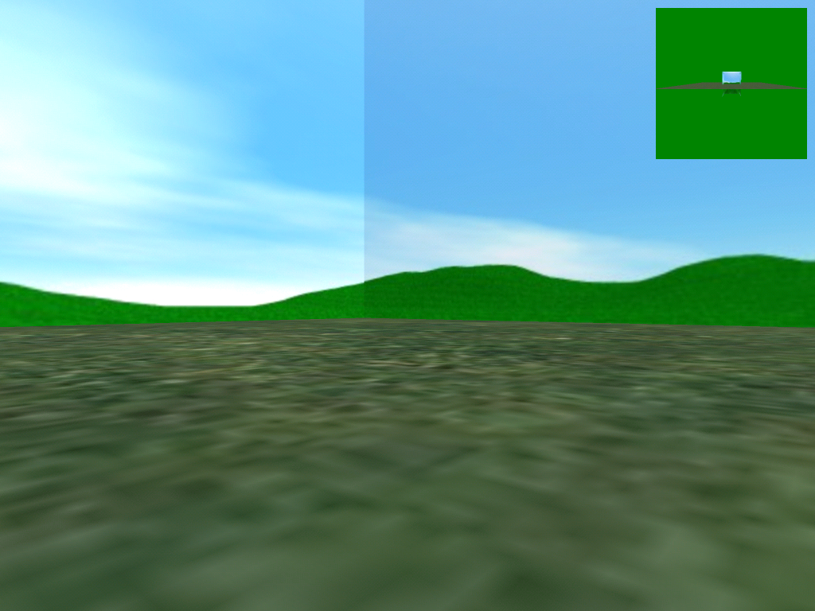

Figure 6 - Skybox scene with visible seam

Top View Side View

Figure 7 - Enlarged skybox walls extending through each other

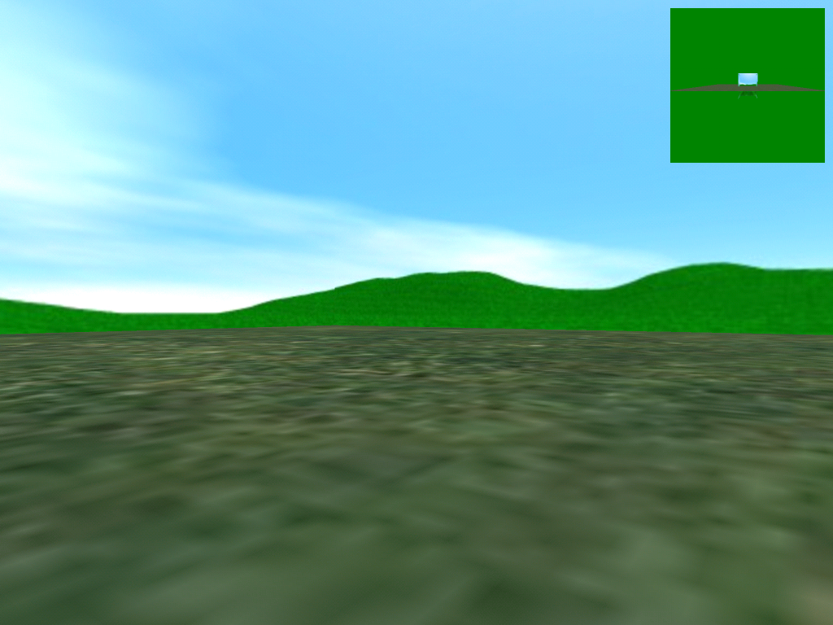
Figure 8 - Skybox without visible seams

Seamless Skyboxes - Use of Clamping

The second technique is the use of texture clamping with the DarkBASIC Professional™ command:

SET OBJECT TEXTURE Object Number, Texturing Mode, Mipmap Flag

The Texturing Mode (also known as the texture wrapping mode) determines how pixels are handled at or near image edges. Textures are mapped using a U-value and a V-value (see Figure 5), which represent horizontal and vertical, respectively. If the object being textured is larger or smaller than the texture image, the U- and/or V-values may be changed, i.e., the image is expanded or compressed (scaled) to fit. When this occurs, the Texture Mode can be employed to affect how the textures are applied and how pixels may be blended together at image edges.

Texture Wrapping Modes:

Mode 0 = (default) the texture is repeated over and over.
Mode 1 = (mirror) as above except, alternate images are reversed.
Mode 2 = (clamping) retains the color of the last pixel at the texture's edge and paints with that throughout the out-of-range area.

Texture mode 2 (clamping) is a method of blending pixel colors at edges and making a seamless skybox.

SET OBJECT TEXTURE ObjNbr, 2, 0
TEXTURE OBJECT ObjNbr, ImageNbr

Another parameter of Set Object Texture is the Mipmap Flag (the 0 at the end of the command above). For a skybox object you will normally set this off (0). Mipmapping is a technique to reduce image resolution for distant views. Since our skybox always maintains a fixed, relatively close distance to the player, mipmapping serves no useful function.

Sample Program Tut03.dba

This program implements a skybox that encloses the player. The landscape (matrix) is 3,000 units on each side and the skybox is 600 units on a side. The player has the freedom to move about the landscape using the keyboard arrow keys. You may use the {?} key to display on-screen help (See Figure 9.)

The program has a startup option that permits you to select one of three skybox textures:
- Green field and mountains with a blue sky
- Mars landscape in violent reds, yellows, and browns
- Twilight at sea with a rainbow

As you will see from the on-line help, there are several run-time options that let you visualize some of the problems with skyboxes. You can display fog in one of five colors and can raise or lower the ambient light level from 10 to 100 percent in steps of 10. Also note the inset camera view in the upper right corner that shows placement of the skybox on the matrix. As the player changes position, the inset skybox also moves.

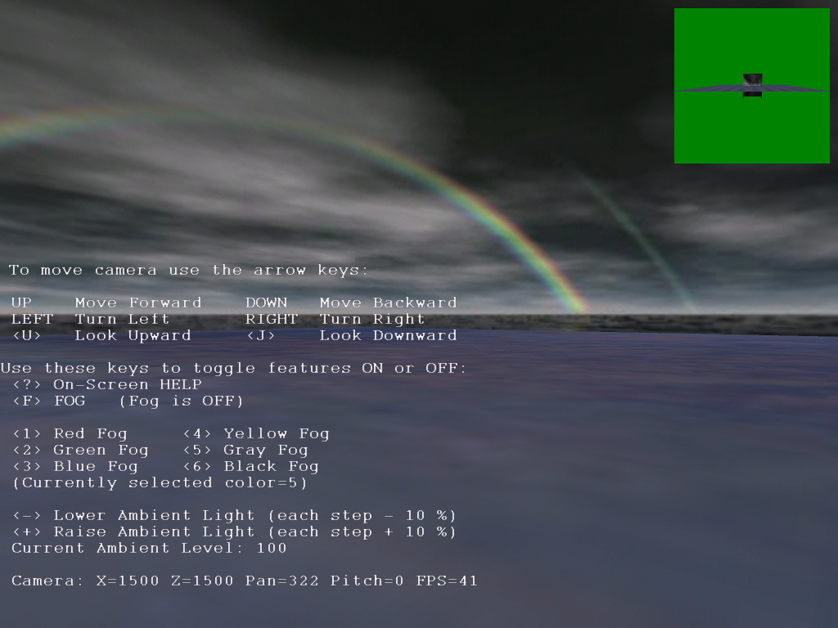

Figure 9 - Example program Tut03.dba on-screen help

Skybox Construction

Before getting into the actual commands used to build a skybox, we need a brief review about rotation and positioning 3D objects in world space.

DarkBASIC Professional uses a left-handed coordinate system. As illustrated in Figure 10, this gives us a framework in which to describe how an object is positioned in world space. The Y direction is up and down, the X direction is left and right, and the Z direction is in and out of the screen.

Y+

Z+

X - X+
X=0, Y=0, Z=0

Z -

Y -

Figure 10 - World Space Coordinates

Rotation of objects is clockwise positive around an axis when viewed looking "down" the axis (i.e., when looking from the positive end towards the negative end.

Y+ Z+

X+

Figure 11 - Object Rotation Clockwise
Constructing a skybox involves both rotation and positioning of each skybox wall object. A skybox wall can be made from either a plain or a box object. For our examples, we will use a plain object. When using the command:

MAKE OBJECT PLAIN Object Number, Width, Height

The object is initially positioned and oriented as shown in Figure 12.

Y+ Z+

Matrix

X+
Front wall Front wall

Original Mesh Object

Back wall

Figure 12 - Initial orientation of object

Note that the skybox is put together around the coordinates X=0, Y=0, and Z=0. After assembly, the skybox is positioned in the middle of the matrix. The texture for each wall is initially applied to the side facing the viewer (- Z direction.) One of the reasons for rotation is to get the textured side correctly facing the player.
Image Orientation

Every object has a rotational center. This is shown as the meeting of the three axes in the middle square in Figure 12. This square represents a new plain object which is centered on X=0, Y=0, and Z=0. As mentioned earlier, the orientation of the original pictures will dictate exactly the correct combination of commands for each skybox wall. For our examples, we will assume our pictures are oriented as shown here in Figure 13.

1-Top 2-Front 3-Right 4-Back 5-Left

Figure 13 - Skybox images

The above images are for the skybox left, back, right, front, and top sides, respectively. Every plain object is created with its front facing the viewer.

When we position a plain object it will be shifted in a specified direction by one-half its width or by a full width. Rotations will be either: 0, 90, 180, or 270 degrees.

Making a Plain Object

A skybox created from plain objects must be fabricated in a specific manner that permits moving the skybox as a whole, not five individual moves. This is accomplished by making a central object with a zero-size. This will be the base object that has five sides attached as limbs. The following commands set up the base object:

BaseObj = 1
CopyObj = 2
LimbNbr = 1

WallSize# = 600.0

Make Object Plain BaseObj, 0, 0
Make Object Plain CopyObj, WallSize#, WallSize#
Make Mesh From Object CopyObj, CopyObj

And now for some walls...

` Top
Add Limb BaseObj, 1, CopyObj
Offset Limb BaseObj, 1, 0, (WallSize#/2), 0
Rotate Limb BaseObj, 1, 270, 0, 0
Scale Limb BaseObj, 1, Enlarge#, Enlarge#, Enlarge#
` Front
Add Limb BaseObj, 2, CopyObj
Offset Limb BaseObj, 2, 0, 0, (WallSize#/2)
Scale Limb BaseObj, 2, Enlarge#, Enlarge#, Enlarge#
` Right
Add Limb BaseObj, 3, CopyObj
Offset Limb BaseObj, 3, WallSize#/2, 0, 0
Rotate Limb BaseObj, 3, 0, 90, 0
Scale Limb BaseObj, 3, Enlarge#, Enlarge#, Enlarge#
` Back
Add Limb BaseObj, 4, CopyObj
Offset Limb BaseObj, 4, 0, 0, (WallSize#/2-WallSize#)
Rotate Limb BaseObj, 4, 0, 180, 0
Scale Limb BaseObj, 4, Enlarge#, Enlarge#, Enlarge#
` Left
Add Limb BaseObj, 5, CopyObj
Offset Limb BaseObj, 5, (WallSize#/2-WallSize#), 0, 0
Rotate Limb BaseObj, 5, 0, 270, 0
Scale Limb BaseObj, 5, Enlarge#, Enlarge#, Enlarge#All my best moves

The above code extract illustrates that each skybox wall is constructed with the same group of instructions. A new limb is offset and rotated into position and then the wall is scaled as discussed earlier about texture enlargement.

Skybox Summary Table:

MovePlus = (WallSize# / 2)
MoveBack = (MovePlus - WallSize# / 2)

MovePlus moves one-half a wall length in a positive axis direction.
MoveBack value must be a one-half negative move in the minus axis direction.

Image X, Y, Z Offsets X, Y, Z Rotations

1 - Top 0, MovePlus, 0 270, 0, 0
2 - Front 0, 0, MovePlus 0, 0, 0
3 - Right MovePlus, 0, 0 0, 90, 0
4 - Back 0, 0, MoveBack 0, 180, 0
5 - Left MoveBack, 0, 0 0, 270, 0

Once the skybox is assembled, add the textures for all five walls.

Texture Limb BaseObj, 1, 1
Texture Limb BaseObj, 2, 2
Texture Limb BaseObj, 3, 3
Texture Limb BaseObj, 4, 4
Texture Limb BaseObj, 5, 5

Finally, center the skybox on the landscape (assume a matrix 3000x3000):

POSITION OBJECT BaseObj, 1500.0, 0.0, 1500.0

Further Exercises

Skyboxes can be more versatile than just providing a landscape. For example, you have designed a game with multiple outdoor levels and a small skybox is practical. An option is to use multiple skyboxes on the same matrix where each represents a different sky or room and level. When the player reaches some key object within each skybox, the "changing to level x" screen would be displayed and then the player would appear in the next skybox near an entry point.

Try the texture clamping technique on your PC. On the tutorial example program, it did not have an appreciable effect.

Summary

This was a lot of detail about fairly common techniques. From the history we quickly dived into the finer points of skybox structure, components, and programming. The goal was to give you enough information so that you not only can decide between skyboxes, skyspheres, and other worldly creation technologies, but also to be able to quickly program a skybox for your game.

If you need even more grounding in skyboxes, follow up on some of the Additional Reading and References.

Additional Reading and References

3D Graphics Programming Games and Beyond, by Sergei Savchenko, Sams Publishing

Texture Mapping as a Fundamental Drawing Primitive, by Paul Haeberli and Mark Segal
http://www.sgi.com/grafica/texmap/

Creating Backgrounds for 3D Games, by Gavin Bell, Gamasutra™
http://www.gamasutra.com/features/visual_arts/19981023/skybox_01.htm

Skyboxes without Seams, by Marco Monster
http://home.planet.nl/~monstrous/skybox.html

How to setup an efficient skybox, by Tim Hackett
http://gamedevnetwork.com/article.php?aid=26

